Day 2 – AWS Global Infrastructure & Virtualization Fundamentals
Today’s Topics
- Methods of Connecting to AWS Cloud
- AWS Global Infrastructure
- Regions & Availability Zones
- Data Centers & Physical Servers
- High Availability (HA)
- Disaster Recovery (DR)
- Virtualization & Hypervisors
- Business Value of Cloud

1. Methods of Connecting to the Cloud
Cloud providers like Amazon Web Services provide multiple ways to connect and manage infrastructure.
A. AWS Console (Portal)
AWS Console is a web-based interface used through a browser.
Uses
- Create servers
- Manage storage
- Configure networking
- Monitor applications
- Check billing
Architecture Flow
User → Browser → AWS Console → AWS Services
Real-Time Example
Open:
- aws.amazon.com
- Login
- Open EC2 Service
- Launch Instance

B. AWS CLI (Command Line Interface)
CLI allows engineers to manage AWS resources using commands.
Example Command
aws ec2 describe-instances
Benefits
- Faster automation
- Useful for scripting
- Preferred in DevOps
Diagram
User → Terminal → AWS CLI → AWS Infrastructure

C. Terraform / Infrastructure as Code (IaC)
Terraform creates infrastructure using code files.
Example
resource "aws_instance" "server" {
ami = "ami-12345"
instance_type = "t2.micro"
}
Diagram
Terraform Code → Terraform Engine → AWS Resources

2. AWS Global Infrastructure
AWS has one of the world’s largest cloud infrastructures with:
- Multiple Regions
- Availability Zones
- Data Centers
- Edge Locations
AWS currently operates many Regions and Availability Zones globally.

AWS Global Infrastructure Diagram
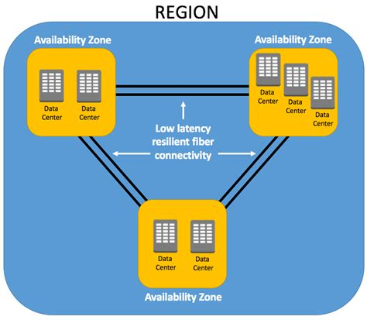
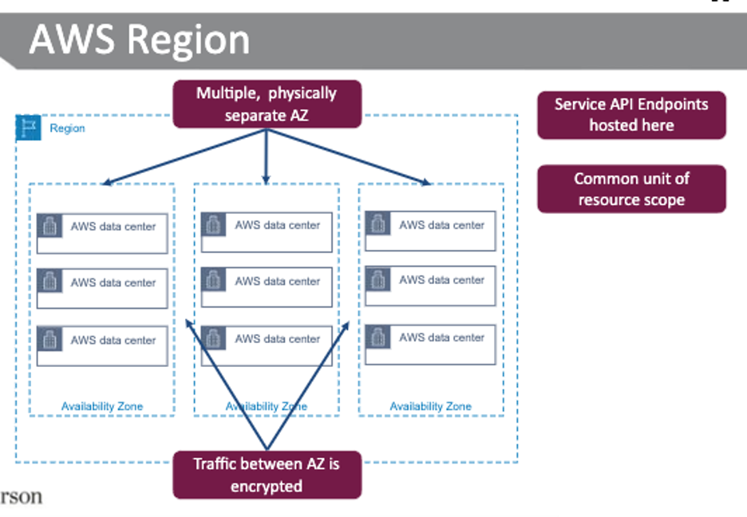
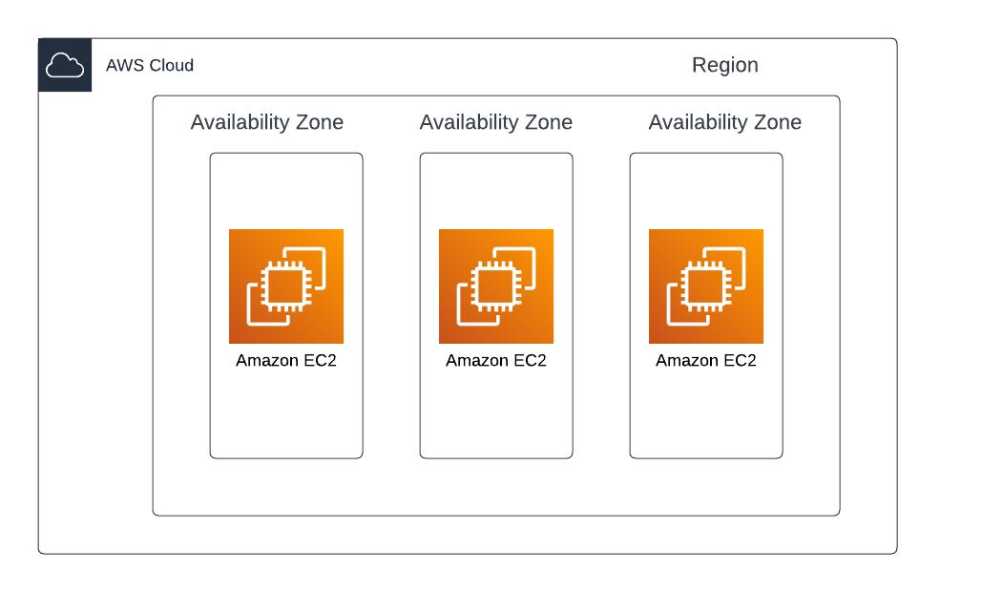
AWS infrastructure is organized as:
Region
↓
Availability Zone
↓
Data Center
↓
Rack
↓
Physical Servers
AWS Regions contain multiple isolated Availability Zones connected using low-latency networking.

3. Regions
A Region is a geographical location where AWS maintains infrastructure.
Examples
- Mumbai
- Singapore
- Tokyo
- US East (N. Virginia)
Why Regions?
- Low latency
- Data compliance
- High availability
- Better performance
Diagram
World
├── India Region
├── US Region
├── Europe Region
└── Singapore Region

4. Availability Zones (AZs)
Each AWS Region contains multiple Availability Zones.
Each AZ contains:
- One or more Data Centers
- Separate power
- Separate networking
- Separate cooling
AWS recommends deploying applications across multiple AZs for fault tolerance.

Availability Zone Diagram
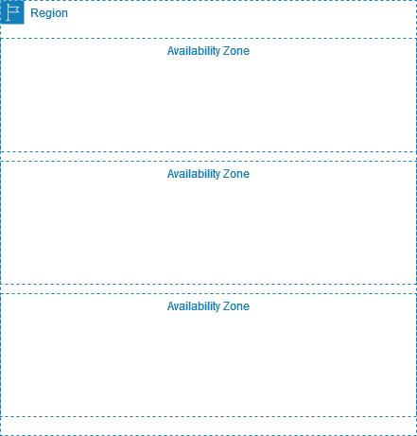
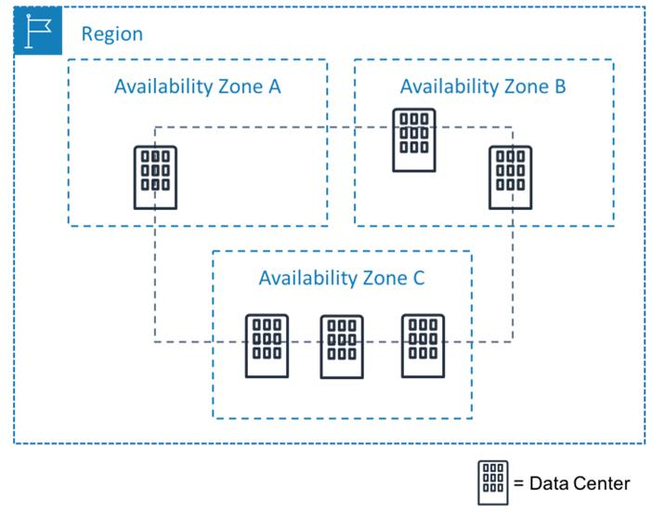
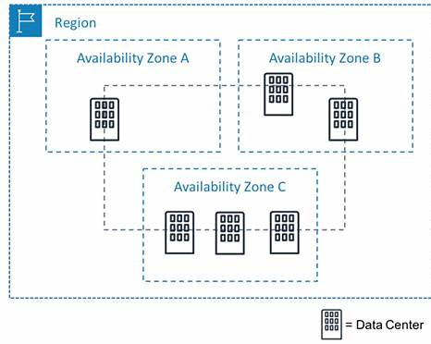
Example
Mumbai Region:
- ap-south-1a
- ap-south-1b
- ap-south-1c
Diagram
Mumbai Region
├── AZ-1
├── AZ-2
└── AZ-3

5. Data Centers, Racks & Physical Servers
Data Center
A secure building that contains:
- Servers
- Storage
- Networking devices
- Cooling systems
- Power systems

Rack
A rack contains multiple physical servers.
Rack Diagram
Data Center
↓
Rack
├── Server 1
├── Server 2
├── Server 3
└── Server 4

Physical Server
A physical server is actual hardware containing:
- CPU
- RAM
- Storage
- Network cards
Without virtualization:
1 Physical Server = 1 Operating System
With virtualization:
1 Physical Server
├── VM-1 Web Server
├── VM-2 App Server
└── VM-3 Database Server

6. High Availability (HA)
High Availability means deploying applications across multiple Availability Zones inside the SAME Region.
Goal
Avoid downtime.
HA Diagram
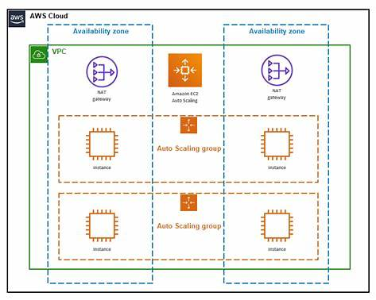
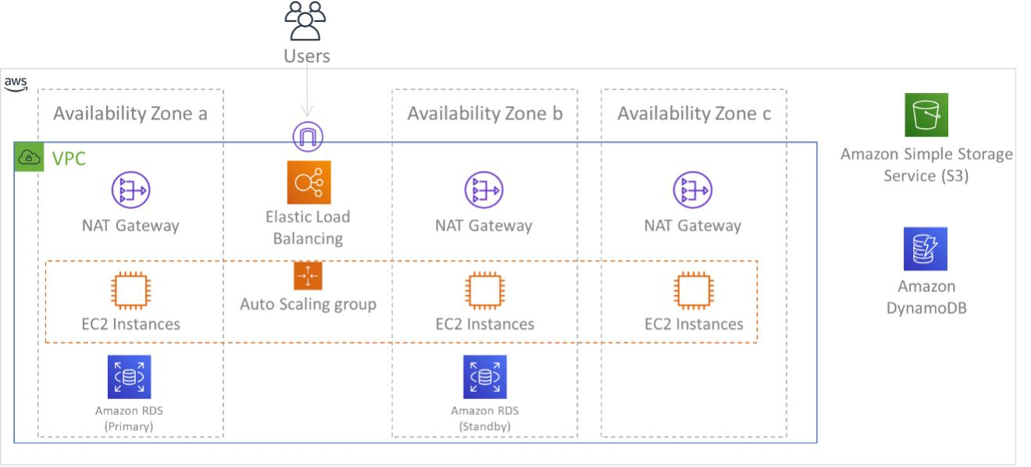
Example
Application deployed in:
- AZ-1
- AZ-2
- AZ-3
If one AZ fails:
- Application continues from another AZ.
AWS recommends multi-AZ deployments to improve reliability and fault tolerance.

7. Disaster Recovery (DR)
Disaster Recovery means deploying applications across MULTIPLE Regions.
Example
- Primary Region → Mumbai
- Backup Region → Singapore
DR Diagram
Mumbai Region → Primary Site
Singapore Region → Disaster Recovery Site
Difference Between HA & DR
Feature | High Availability | Disaster Recovery
Deployment | Multiple AZs | Multiple Regions
Purpose | Prevent local failure | Recover from regional disaster
Cost | Medium | High

8. Virtualization
Virtualization allows multiple virtual machines to run on a single physical server.
Benefits
- Better resource utilization
- Reduced hardware cost
- Easy scaling
- Isolation between applications

Virtualization Diagram
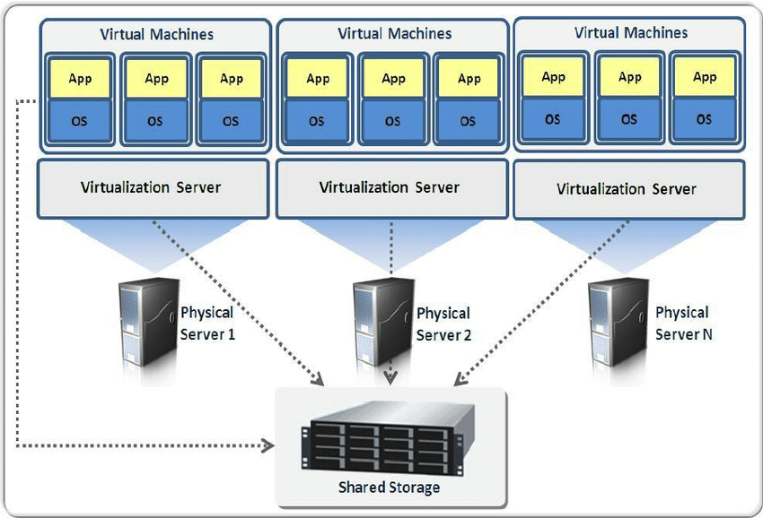
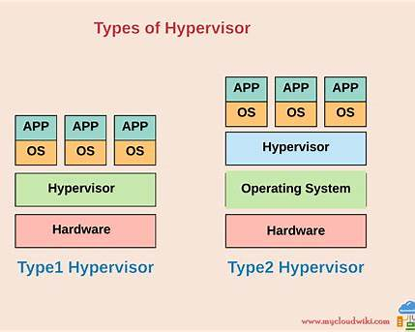
Virtualization Stack
Physical Hardware
↓
Hypervisor
↓
Virtual Machines
The hypervisor allocates CPU, memory, and storage resources to each virtual machine.

9. Hypervisors
A Hypervisor is software used to create and manage Virtual Machines.
Common Hypervisors
Provider | Hypervisor
AWS | Xen
Azure | Hyper-V
Google Cloud | KVM
VMware | ESXi
Diagram
Physical Server
↓
Hypervisor
↓
VM-1 VM-2 VM-3

10. Business Value of Cloud
Companies move to cloud for many advantages.
A. Cost Savings
No need to maintain:
- Physical servers
- Cooling
- Data center buildings

B. Faster Deployment
Traditional setup:
- Weeks or months
Cloud setup:
- Minutes

C. Scalability
Servers can increase automatically during traffic spikes.
Diagram
Low Traffic → 2 Servers
High Traffic → 10 Servers

D. Flexibility
Cloud provides:
- Small servers
- Large servers
- GPU servers
- Storage options

Important Warning for Students
Cloud is easy to start, but:
- Unused resources cost money
- Poor monitoring increases bills
- Proper architecture is important

Real-Time Interview Question
Question
Why should applications be deployed across multiple Availability Zones?
Answer
Applications are deployed across multiple Availability Zones to achieve High Availability. If one Availability Zone fails because of power, networking, or hardware issues, the application continues running from another Availability Zone without downtime.

Summary
Today we learned:
- Methods of connecting to AWS
- AWS Global Infrastructure
- Regions and Availability Zones
- Data Centers and Physical Servers
- High Availability and Disaster Recovery
- Virtualization and Hypervisors
- Business benefits of cloud computing

